# Then and Now Content Overview

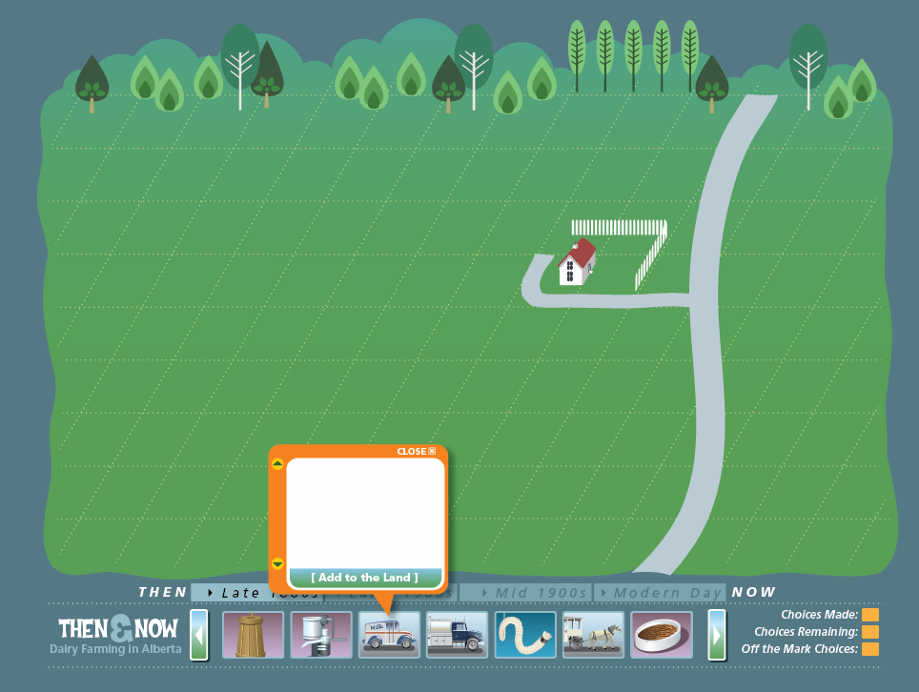**Grade 4: Inquiry One**

<Entry directions from magazine cover>

Has milk always been sold in stores? Are cows milked by farmers or by machines? Find out how dairy farming has changed over time. Click “Enter” to jump back in time to a farmer’s field in the late 1800s. Follow the directions to create a modern dairy farm!

<Print function is accessed when each eras is completed.>

<Time travel directions to appear when flash application is accessed from magazine cover page.>

<Entry visual for Flash Application>

<Time travel directions>

Use the scroll bar on the bottom of the landscape to select artifacts that belong in each of four **eras**, or time periods. You will start in the late 1800s and “travel” through the dairy time line!

Click on each artifact to find information and clues. Then, decide if the artifact belongs in the era. Click the “Add” button to add it to the landscape. Once you have found all the artifacts that belong to an era, you will be able to travel through time to the next era. You must find all the artifacts that belong to an era before moving on!

Keep track of your choices in the lower left corner of the screen. Look for the artifacts that were replaced over time because of advances in technology. You’ll also find some artifacts that were used over many years. You can access the information and clues for all the artifacts at any time.

Watch your “Choices” trackers at the bottom of the screen. If you select an icon that does not belong in the era, it will show in the “Off the Mark Choices” box.

When you complete each era, you will also be able to print all of the artifacts that make up that time period! Just click on the Print icon that appears.

Remember that your time travel adventure is session-based. This means that you must complete your time travel before you leave this site, or you will have to start over.

<**START**>

< The flowcharts and visuals that follow shows the progression of artifacts as they belong to each era, as well as artifacts and screen scenes. Each artifact path shows how each artifact will be replaced. If arrows move across the era, the artifact from the previous era will remain on the landscape. The text boxes provided after the visual screens contain text for each artifact, which are colour-coded for each era.>

* **Late 1800s**
* **Early 1900s**
* **Mid 1900s**
* **Late 1900s to Present Day <Perry: note change in this label>**







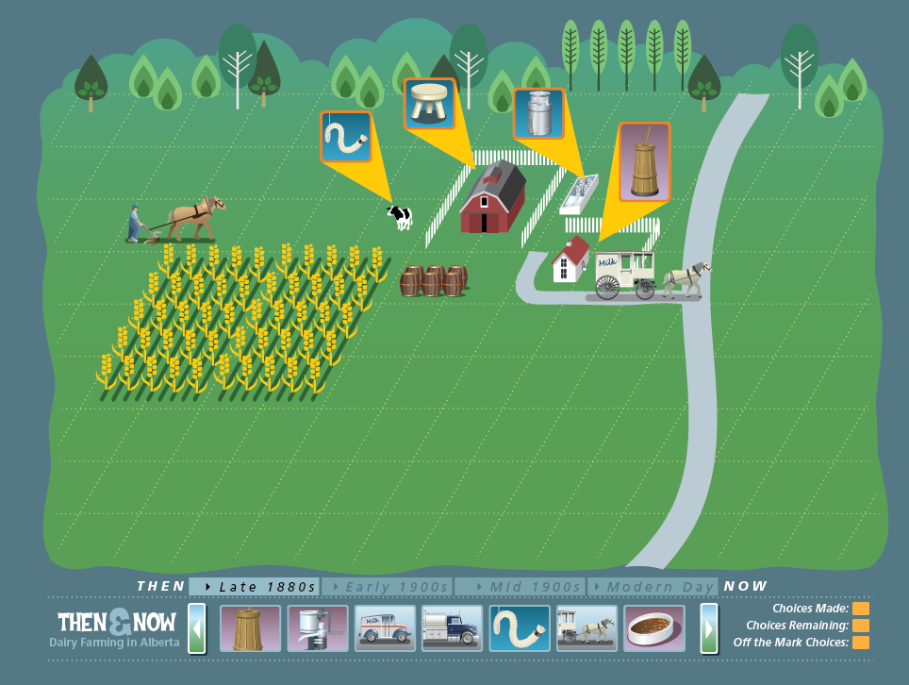

<Message when all choices made in late 1800s; travel from late 1800s to early 1900s>

You’ve done all you can in this era! The early 1900s brought new inventions and developments in dairying. Find out what changed after the “turn of the century.”

<Message when incorrect choice for an era is made>

This artifact is “off the mark” and does not belong in this era.

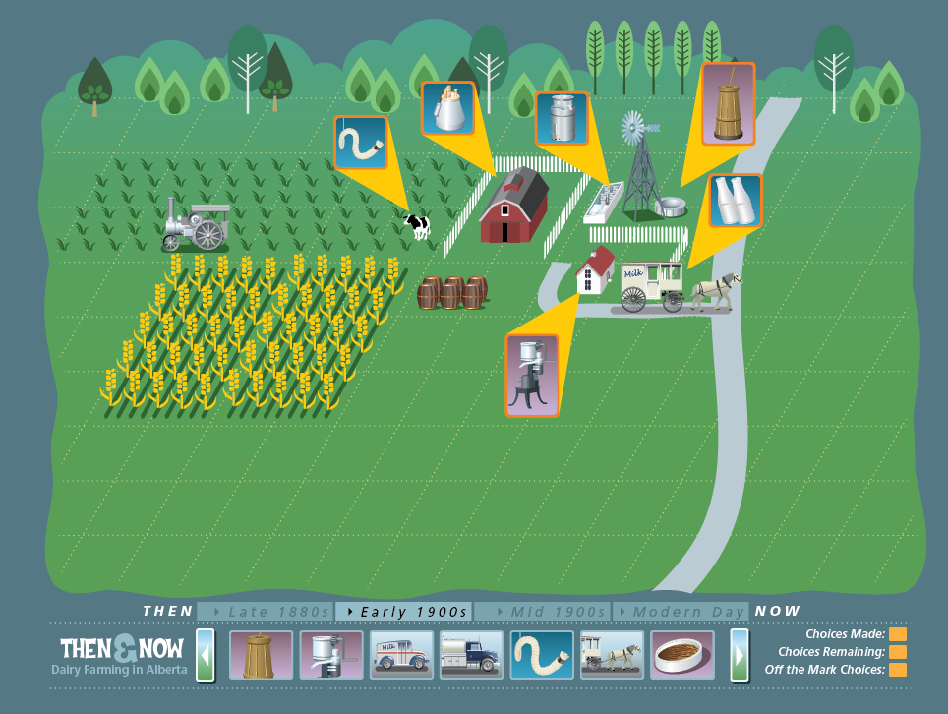

<Message when all choices made in early 1900s; travel from early 1900s to mid 1900s; automatic house and road upgrade occurs on landscape>

You’ve done all you can in this era! Technology changed dairy farming drastically, starting in the 1950s. What changes in the landscape do you see happening?

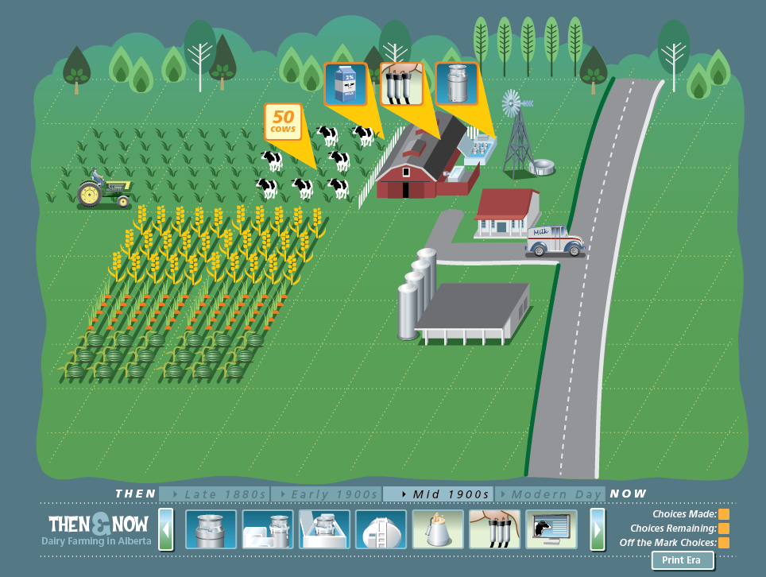

<Message when all choices made in mid 1900s; travel from mid 1900s to current day>

You’ve made it to present day! What is dairy farming like today? What technology do dairy farmers depend upon? Find out by finishing your dairy timeline.

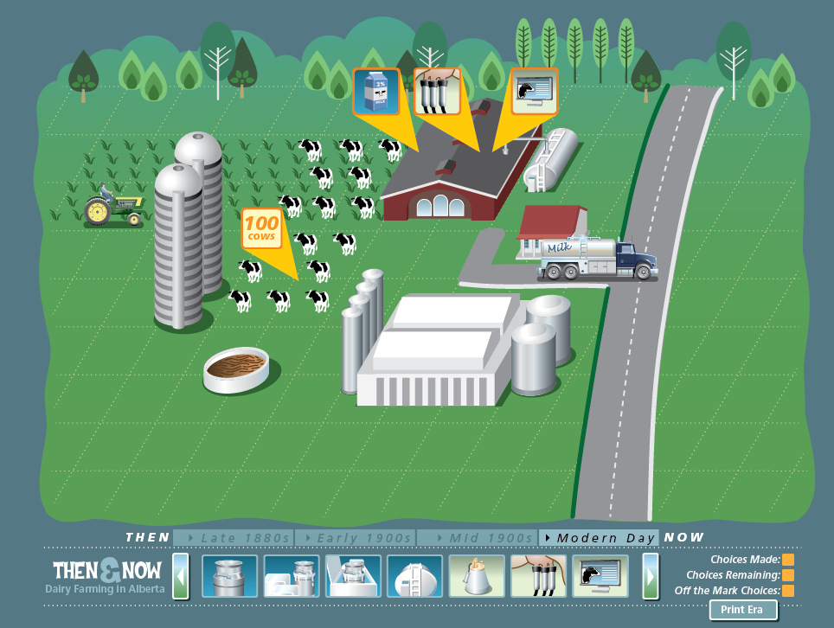

<Message when choices completed; include access to **PRINT** function>

You’ve finished the dairy timeline! What change do you think most affected dairy farming over the years? Print the dairy artifacts to help you answer this question!

# TEXT

<herd of 100 cows>

Alberta has 613 dairy farmers, with an average herd size of 100 cows. As of 2008, there were approximately 80 000 milk cows and dairy heifers in Alberta. A heifer is a female cow that has not had a calf. In 2010, these cows produced 653 million litres of milk which were transported to the 20 registered dairies in Alberta that receive and process raw milk.

<herd of 50 cows>

In the mid-1900s, most farmers did not have more than 50 head of cattle.

<cow stays; no new artifact replaces it>

<single tethered cow>

Most farms in the 1800s were mixed farms. This meant that farmers raised cows, chickens, and pigs for their own use. Many also grew their own crops.

<steam thresher>

Steam threshers were used in the early part of the 1900s to harvest grains and food crops. Tractors were invented, but they were large and difficult to use. However, many farmers continued to use horses and ploughs to prepare soil for seeding.

<tractor stays; no new artifact replaces it>

<gasoline tractor>

For the first time, there were more farmers using gasoline powered tractors than horse pulled ploughs. Tractors were built with ploughs and combines, which prepared and seeded the soil for crops.

<hand held plough and horse>

Crops were harvested by hand. A work horse pulled a plough to prepare the soil for seeding.

<field with different crops>

As farmers learned more about what healthy cows needed to eat, more nutritious feed was developed. This feed provided cows with a healthier diet during the winter months.

<modern silo>

Most cow feed is grown on a farm. Cows are often fed a diet with lots of fibre. Their feed can include high quality hay (4 kg/day), silage (16 kg/day), mixed grains (10 kg/day), salt, vitamins, and minerals. Silage is a mixture of grasses and grains fermented in a storage tank. This storage tank is also called a silo.

<grazing pasture>

As farmers increased the number of dairy cows they had, they needed more grazing pasture land.

<grain field; wheat>

Farmers who owned enough land used grazing pastures to feed their cattle. Some farmers grew wheat and hay to use as winter feed.

<computerized monitor>

A modern milking parlour includes measuring systems and computers that keep track of how much milk each cow gives. These systems can also identify each cow as it enters the parlour.

<herringbone milking machine>

The invention of a “herringbone” milking machine allowed farmers to milk up to 60 cows in one hour. The herringbone milking system guided cows and helped them line up for milking.

<early milking machine>

The first milking machines were similar to a traditional milking pail. A milker fit on top of a regular milk pail and milker nipples sucked the milk from the cow’s udder. A large wide strap was put across the cow’s lower back. This allowed the cow to move around naturally when it was being milked. As electric power became more widely used, suction milking machines were used. These machines still had to be lifted and milk poured into milk cans. This had to be done several times for each cow.

<three legged steel>

Early farmers milked cows by hand. They quickly learned to sit beside their cows, not behind them! Milking cows from the side was safer, cleaner, and kept the tail out of the milk pail and the farmer’s face.

<rope>

Milking took place in a barn. The cows were held in place for milking with a rope.

<water well>

Before refrigeration, milk was kept cool by pumping cold underground water around milk containers. When refrigerators were invented, milk cans were placed in a cooled water bath. In some places, windmills kept the water moving.

<milk pipeline and holding tank>

The milk pipeline was invented to reduce the need for a farmer to carry large heavy buckets of milk from each cow to the milk house. The pipeline pulled the milk from the milker nipples on the cow’s udder to the milk house storage tank. Storage tanks were made of stainless steel and often had a cooling system.

<milk on ice>

Fresh milk was used as quickly as possible. Bacteria in fresh milk caused it to spoil in a few days, so milk was often kept cool with blocks of ice.

<bulk milk tank>

A bulk tank is a refrigerated stainless steel tank in which a large amount of milk is cooled quickly. The milk can be stored in the tank until it is picked up by a truck.

<milk cooler >

As more milking machines started to be used, larger milk coolers were used to keep the milk cold. These coolers used evaporation to remove the heat from the milk. Milk could be cooled faster.

<steel milk can stays; no artifact for this era>

<steel milk can>

Milk cans were used to hold the milk and keep it cool. These cans were made of steel.

<steel milk can stays; no new artifact replaces it>

<milk carton>

Glass bottles gradually were replaced by plastic milk jugs and paper milk cartons. The first milk cartons did not have a spout and had to be cut open to pour the milk.

<glass milk bottle>

Milk was sold directly by farmers. In some communities, a milkman delivered the milk to homes in glass bottles.

<barrels>

Farmers often made extra money by filling barrels with milk in the morning and bringing the barrels on a wagon to a market in a nearby village or town.

<milk carton stays; no new artifact to replace it>

<horse/wagon stays; no new artifact to replace it>

<horse and wagon>

The most common method used to transport milk in early days was the horse and wagon. Farmers brought their extra milk and cream to towns to sell.

<milk transport truck with stainless steel trailer tank>

Milk transport trucks now take milk from farmers to dairies, where the milk is made into many products. These transport trucks pump the milk from the farmer’s holding tank into a stainless steel tank on the truck.

<home delivery truck>

Milk was delivered directly to many homes in cities and towns throughout the 1960s and 1970s.

<dairy plant>

Processing plants, or dairies, started to be used in the mid 1900s to process raw milk into different products, such as butter and cheese.

<butter churn>

Butter was made by hand by early farmers. Wooden tubs called butter churns were found in many farmhouses.

<cream separator >

Cream separators were used to skim the butter fat from the milk. Butter fat was used to make butter and cheese.

<automated dairy plant>

Dairies today must be registered with the government or have a provincial license. This registration or license says that the dairy meets safety and health requirements for making food products. A dairy plant inspector inspects the dairies to ensure they are clean and safe. They also make sure that proper processes are used to make healthy dairy products. In today's automated dairy plants, milk is never exposed to air, light, or human hands. Milk is kept cold and stored in insulated silos, large containers used for storage, until it is processed and packaged.

<milking parlour >

Milking parlours are used on many dairy farms to help handle large herds of cows. The milking parlour is built so that cows are on a platform. This allowed the farmer to milk without having to bend over all the time.

<larger and longer barn>

Inventions such as the milk pipeline and smaller milking machines allowed farmers to milk more cows at once. Dairy farmers started to build longer and larger barns.

<barn stays; no new artifact replaces it>

<barn>

Farmers built their barns by hand, sawing logs for walls and beams. Barns were used to provide shelter for farm animals and store hay and grains.

<manure storage>

Manure produced by cows is kept in special storage facilities until the weather and field conditions are right for spreading. Farmers then work the manure back into the soil for crop production or sell it as a natural fertilizer.

Note: There will be an “upgrade” to the farmhouse and road when a student completes Era 2 and moves on to Era 3.